PROJECT DOCUMENTATION

EduGenie
Google Gemini Powered Learning Assistant
A Lightweight, AI-Driven Educational Platform Built with FastAPI, Google Gemini, and a Locally-Run Instruction-Tuned Model

Technology Stack
FastAPI  Backend & REST API | Jinja2 + HTML/CSS  Frontend UI | Google Gemini  Cloud AI Reasoning | LaMini-Flan-T5  Local Explanation Model

Table of Contents
1. Project Description & Overview
2. Scenarios
3. Architectural Diagram & Folder Structure
4. Prerequisites & Environment Setup
5. Core Functionalities & Module Implementation
6. Backend API Development & Frontend Integration
7. Deployment & Functional Testing
8. Conclusion, Challenges & Future Enhancements
9. Submission Details

1. Project Description & Overview

1.1 Overview
EduGenie is a lightweight, AI-powered educational assistant that simplifies learning through generative AI. Designed for students of all academic levels — from school learners to self-taught professionals — EduGenie acts as a personal AI tutor, available on demand through a clean, browser-based interface.
The application is engineered to run efficiently on modest hardware, including devices such as the Mac M1, by combining the reasoning power of a cloud-based large language model with a lightweight, locally-run instruction-tuned model for simpler tasks. This hybrid architecture keeps the application fast, cost-efficient, and accessible to a broad range of learners and developers.

1.2 Target Audience
- School and college students seeking quick, reliable academic support
- Self-learners exploring new subjects without a formal instructor
- Educators and content platforms looking to supplement teaching material
- Developers and students studying applied Generative AI / LLM integration

1.3 Key User Capabilities
- Ask questions and receive smart, concise answers
- Understand complex concepts through simplified, student-friendly explanations
- Generate multiple-choice quizzes from any topic or passage
- Receive personalized, structured learning recommendations
- Summarize large educational passages into concise revision notes

1.4 Technology Stack
Layer | Technology | Purpose
Backend Framework | FastAPI (Python) | High-performance REST API and routing
ASGI Server | Uvicorn | Runs and serves the FastAPI application
Frontend | HTML5, CSS3, Jinja2 | Server-rendered templated web interface
Cloud AI Model | Google Gemini (gemini-3.8-flash) | Q&A, Summarization, Quiz Generation, Learning Paths
Local AI Model | MBZUAI/LaMini-Flan-T5-783M | Lightweight concept explanation, offline-capable
Environment Config | python-dotenv | Secure API key management via .env
Data Interchange | JSON | Structured quiz and API responses

Design Principle: EduGenie deliberately splits AI workloads between a cloud model (Gemini) for tasks requiring advanced reasoning and structured output, and a compact local model for simple explanatory text — balancing accuracy, cost, and responsiveness.

2. Scenarios
The following real-world scenarios illustrate how different learner profiles interact with EduGenie's five core modules in everyday study situations.

Scenario 1 — Quick Factual Lookup (Q&A Module)
A student researching oceans and rivers for a geography assignment opens EduGenie and types, “Which is the largest ocean?” into the Q&A box. Within seconds, Gemini returns a direct, accurate answer — “The Pacific Ocean” — along with a short supporting fact, saving the student a manual web search.

Scenario 2 — Self-Assessment Before an Exam (Quiz Module)
A student preparing for a mathematics test wants to gauge her understanding of “The Pythagoras Theorem.” She enters the topic and clicks Generate Quiz. EduGenie instantly produces three multiple-choice questions with four options each. As she answers, the app immediately confirms correct responses and reveals the right answer when she selects incorrectly — turning revision into an interactive, self-paced assessment.

Scenario 3 — Structured Skill Building (Learning Path Module)
A learner new to SQL wants a clear roadmap rather than scattered tutorials. He requests a learning path for “SQL,” and EduGenie generates a structured, adaptive plan — progressing from beginner fundamentals (SELECT, WHERE, filtering) through intermediate joins and subqueries, to advanced topics like stored procedures and performance tuning — complete with time estimates and curated resource suggestions.

3. Architectural Diagram & Folder Structure

3.1 Request Flow — Architectural Diagram
Every interaction with EduGenie follows a consistent, predictable path: user input is captured by the frontend, routed through the FastAPI backend to the correct AI module, and the generated result is displayed back in the browser in real time.
START
User opens EduGenie in the browser
↓
FRONTEND
User submits input via an HTML form (Jinja2-rendered)
↓
FASTAPI BACKEND
Based on the endpoint called, routes the request to the matching module
↓
Explanation Module  /explain/ | Q&A Module  /qa | Quiz Module  /quiz | Summary Module  /summarize/ | Learning Path Module  /learn/recommendations
↓
FRONTEND
Displays the JSON response inline, below the relevant form
↓
END
Result shown — user may interact again immediately

3.2 Complete Folder Architecture
The project follows a clean, modular structure — each AI capability lives in its own Python module, kept fully decoupled from the FastAPI routing layer in main.py.
Path | Description
EduGenie/ | Root project directory
main.py | FastAPI application entry point & route definitions
qna.py | Question-answering logic (Gemini)
explanation_module.py | Concept explanation logic (local LaMini-Flan-T5)
quiz_module.py | Quiz generation logic (Gemini + JSON parsing)
summary_module.py | Summarization logic (Gemini)
learning_path.py | Learning path recommendation logic (Gemini)
requirements.txt | Python package dependencies
.env / .env.example | Environment variables (API key, model names)
.gitignore | Excludes .env, venv, and cache files from version control
templates/index.html | Jinja2-rendered HTML frontend
static/style.css | Frontend styling

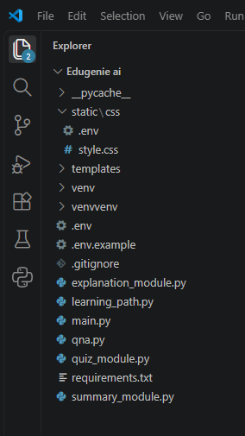
Fig. 3.1 — EduGenie project folder structure, as viewed in the VS Code Explorer

4. Prerequisites & Environment Setup

4.1 Required Software & Libraries
Requirement | Purpose
Python 3.10+ | Core language runtime
FastAPI | Backend web framework
Uvicorn | ASGI server to run FastAPI
Jinja2 | HTML templating engine
python-dotenv | Loads environment variables from .env
google-generativeai | Official Gemini API client
transformers, torch, sentencepiece | Runs the local LaMini-Flan-T5 explanation model
Google Gemini API Key | Authenticates cloud AI requests

4.2 Step-by-Step Setup
- Install Python 3.10 or later from the official Python website, ensuring “Add Python to PATH” is checked during installation.
- Open the project folder in VS Code (File → Open Folder).
- Create and activate a virtual environment:

python -m venv venv
venv\Scripts\activate # Windows
source venv/bin/activate # macOS/Linux

- Install all dependencies:

pip install -r requirements.txt

- Obtain a Google Gemini API key from Google AI Studio (aistudio.google.com → Get API key).
- Create a file named .env in the project root and add:

GEMINI_API_KEY=your_google_gemini_api_key_here
GEMINI_MODEL=gemini-3.8-flash
LOCAL_EXPLANATION_MODEL=MBZUAI/LaMini-Flan-T5-783M

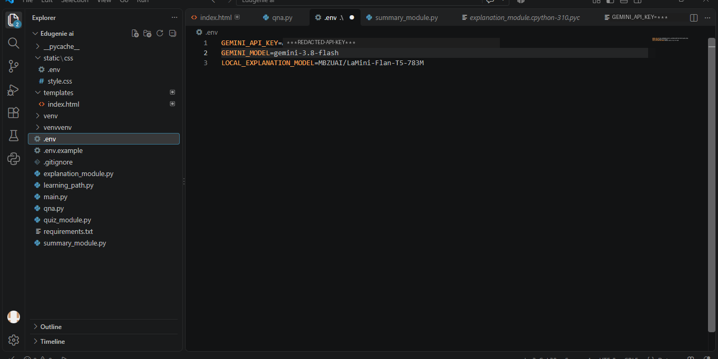
Fig. 4.1 — Environment configuration file (.env) as viewed in VS Code. API key value redacted for security.
Security Note: The .env file must never be committed to version control. It is excluded via .gitignore, and API keys should always be stored here — never hard-coded directly into Python files.

5. Core Functionalities & Module Implementation
EduGenie's intelligence is organized into five independent modules, developed across two milestones: model selection & architecture, followed by core functionality implementation. Each module exposes a single, focused function that main.py wires to a REST endpoint.

5.1 Explanation Module
EduGenie utilizes the LaMini-Flan-T5 model, a lightweight yet powerful generative AI, to deliver educational content in a simplified and highly readable manner. This model is specifically instruction-tuned to provide concise, context-aware responses that break down complex topics into easily understandable language. By focusing on clarity and brevity, EduGenie ensures that learners with minimal background knowledge can grasp essential concepts without feeling overwhelmed — making it especially valuable for beginners, school students, and self-learners.
Core Logic — explanation_module.py

MODEL_NAME = "MBZUAI/LaMini-Flan-T5-783M"

def explain_topic(topic: str) -> str:
tokenizer, model = _load_model()
input_text = (
f"Explain the concept of '{topic}' in a simple and clear way "
f"for a school student."
)
inputs = tokenizer(input_text, return_tensors="pt")
outputs = model.generate(
**inputs, max_new_tokens=150, temperature=0.7,
top_k=50, top_p=0.95, do_sample=True,
)
return tokenizer.decode(outputs[0], skip_special_tokens=True)

Interaction with the AI model: the function is loaded lazily on first request, tokenizes a natural-language prompt, and generates a bounded, temperature-sampled response entirely on local hardware — requiring no internet connection once the model has been downloaded.
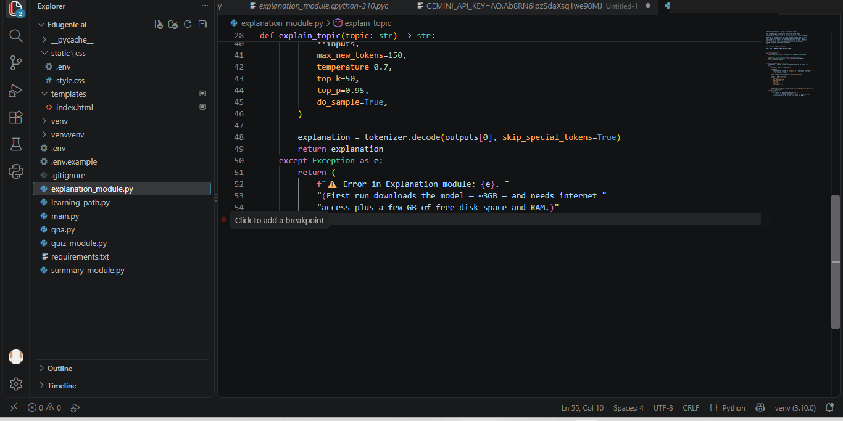
Fig. 5.1 — Explanation module logic in VS Code

5.2 Q&A Module
EduGenie is powered by Google Gemini, enabling it to handle a wide range of general knowledge and academic question-answering tasks with precision. Its advanced understanding and contextual capabilities make it an effective tool for learners seeking accurate, AI-driven assistance across diverse educational topics and subjects.
Core Logic — qna.py

def answer_question_with_gemini(question: str) -> str:
try:
model = genai.GenerativeModel(
model_name="models/gemini-3.8-flash"
)
response = model.generate_content(question)
return response.text.strip()
except Exception as e:
return f"⚠️ Error in QnA: {e}"

Interaction with the AI model: the raw question is sent directly to Gemini's generate_content endpoint. Gemini's contextual reasoning produces a natural-language answer, which is trimmed and returned as-is to the frontend.
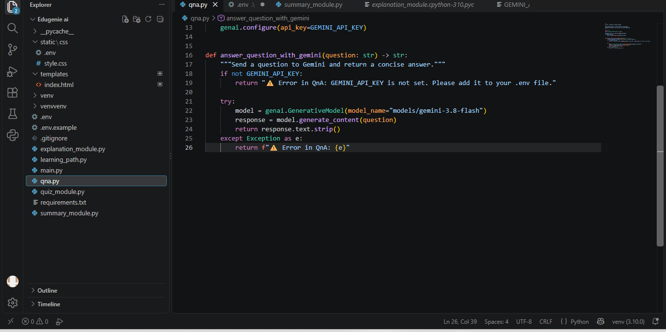
Fig. 5.2 — Q&A module logic in VS Code

5.3 Quiz Module
EduGenie generates three multiple-choice questions (MCQs) from a given passage or topic, each containing four carefully crafted options. It utilizes the Gemini model to comprehend context and meaning, ensuring that questions are relevant and distractors are plausible. The final output is structured in JSON format for seamless frontend integration.
Core Logic — quiz_module.py

def clean_json_block(text: str) -> str:
return re.sub(
r"```(?:json)?\n(.*?)```", r"\1",
text, flags=re.DOTALL
).strip()

def generate_quiz(text: str) -> list:
model = genai.GenerativeModel(
model_name="models/gemini-3.8-flash"
)
prompt = f"""You are a quiz generator...
Format your output as **valid JSON**...
Passage: {text}"""
response = model.generate_content(prompt)
cleaned_text = clean_json_block(response.text.strip())
return json.loads(cleaned_text)

Interaction with the AI model: a structured prompt instructs Gemini to return strictly formatted JSON — an array of question/options/answer objects. Because models occasionally wrap JSON in Markdown code fences, clean_json_block() strips those fences before json.loads() parses the result, with graceful error handling if parsing fails.
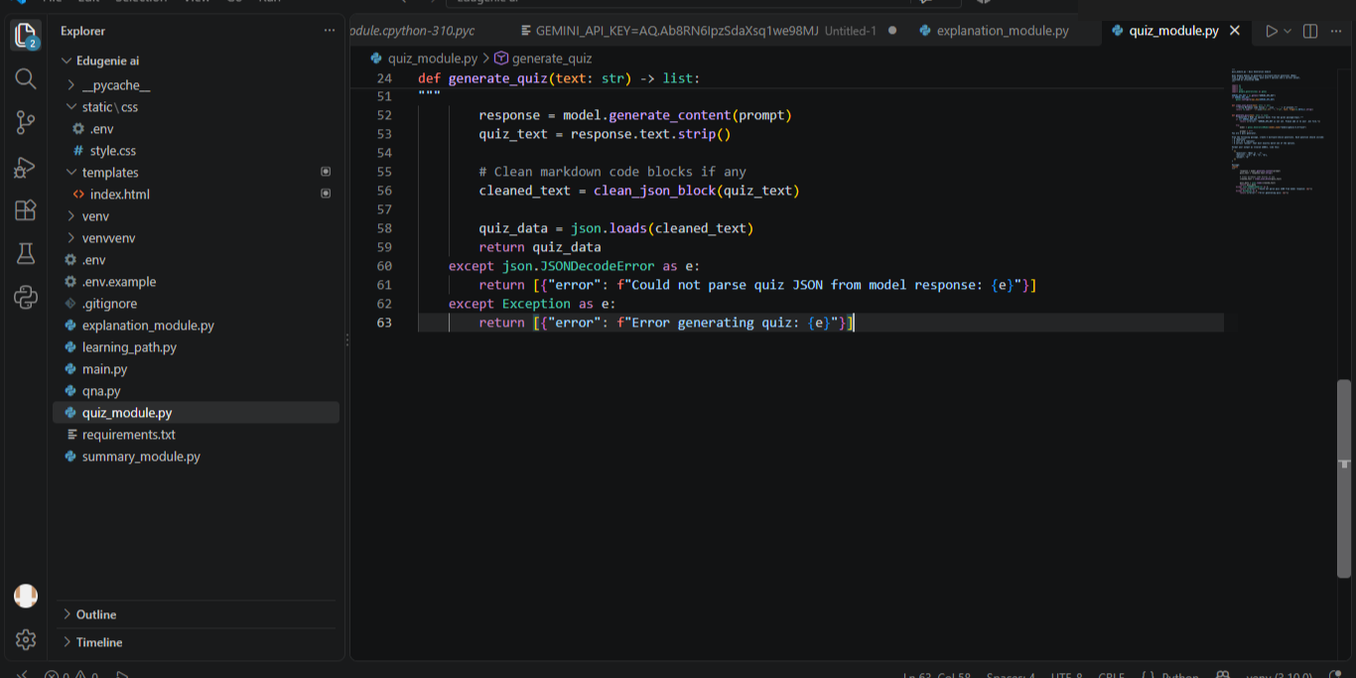
Fig. 5.3 — Quiz generation module logic in VS Code

5.4 Summary Module
This feature leverages Gemini's generative capabilities to summarize long paragraphs into concise, easy-to-understand versions, making it ideal for quick revision. It ensures core information is retained while eliminating redundancy, helping learners absorb key points efficiently without losing clarity or context.
Core Logic — summary_module.py

def summarize_text(text: str) -> str:
try:
model = genai.GenerativeModel(
model_name="models/gemini-3.8-flash"
)
prompt = f"Summarize the following text "
f"in simple language:\n\n{text}"
response = model.generate_content(prompt)
return response.text.strip()
except Exception as e:
return f"⚠️ Error in Summary: {e}"

Interaction with the AI model: the source passage is embedded into an instructive prompt asking for simplified language, and Gemini's response is returned directly — no post-processing is required since the output is free-form prose rather than structured data.
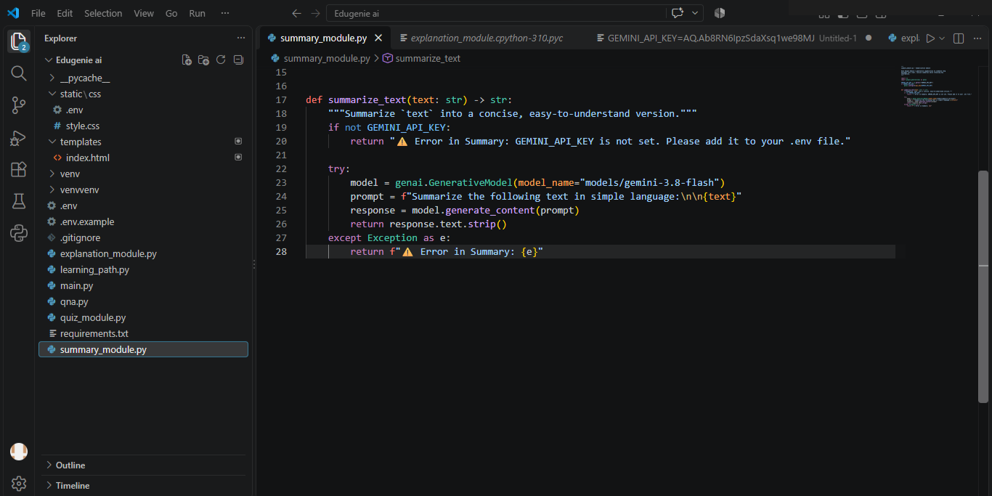
Fig. 5.4 — Summarization module logic in VS Code

5.5 Learning Path Module
The get_learning_recommendations function uses Google Gemini to generate a personalized, structured learning path for any given topic. By crafting a detailed prompt, it instructs the AI to suggest beginner-to-advanced concepts organized by difficulty and supported with useful resources such as videos, articles, or books — ensuring adaptability to the learner's level.
Core Logic — learning_path.py

def get_learning_recommendations(topic: str) -> str:
prompt = f"""You are an AI tutor. The student
wants to learn about: {topic}. Suggest a
structured and adaptive learning path including
key topics, order of learning, and resources.
Include beginner, intermediate, and advanced
levels if needed."""
try:
model = genai.GenerativeModel(
model_name="models/gemini-3.8-flash"
)
response = model.generate_content(prompt)
return response.text
except Exception as e:
return f"❌ Error occurred: {str(e)}"

Interaction with the AI model: the function safely extracts either response.text or response.parts[0].text depending on Gemini's response shape, providing resilient error handling so a malformed API response never crashes the endpoint.
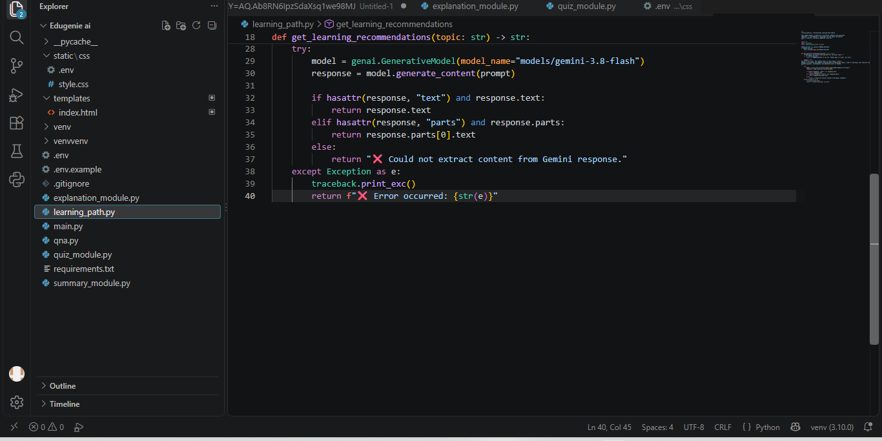
Fig. 5.5 — Learning path module logic in VS Code

6. Backend API Development & Frontend Integration

6.1 FastAPI Endpoints
main.py defines RESTful endpoints for each module and mounts the static/template directories used by the frontend.
Endpoint | Method | Description
/ | GET | Serves the main EduGenie web interface (index.html)
/qa | GET | Answers a question via query parameter
/explain/ | POST | Returns a simplified explanation for a topic
/summarize/ | POST | Returns a concise summary of submitted text
/quiz | POST | Returns a structured 3-question MCQ quiz (JSON)
/learn/recommendations | GET | Returns a structured learning path for a topic
/health | GET | Basic health-check endpoint

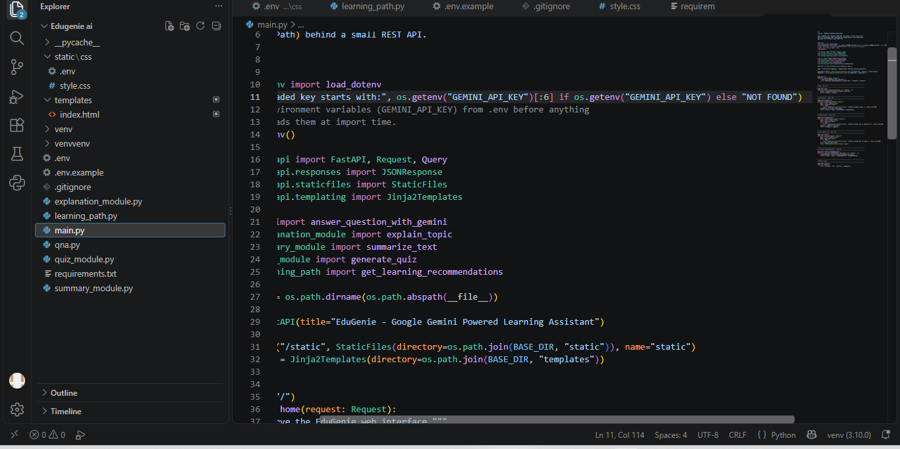
Fig. 6.1 — FastAPI route definitions in main.py

6.2 Frontend — HTML Form Structure
The frontend (templates/index.html) presents five clearly separated cards — one per module — each with a labeled input, a submit button, and a dedicated output container that is populated live via JavaScript fetch() calls, without a full page reload.

<!-- Q&A -->
<section class="card">
<form id="qaForm">
<label><strong>Ask EduGenie a Question:</strong></label>
<input type="text" id="question"
placeholder="Why is the sky blue?" required />
<button type="submit">Get Answer</button>
</form>
<div id="qaResult" class="output"></div>
</section>

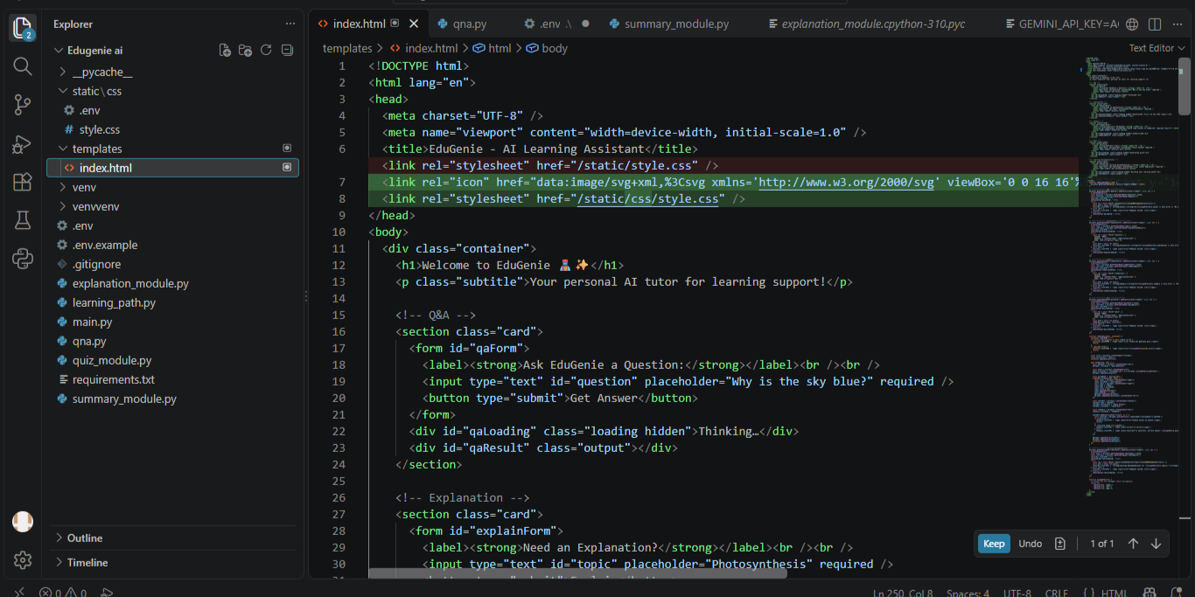
Fig. 6.2 — Frontend template (index.html) rendered in VS Code

6.3 Frontend — Styling
static/style.css provides a clean, responsive card-based layout, with distinct color cues for success (green), failure (red), and interactive quiz feedback — keeping the interface intuitive for learners of all ages.

.quiz-option { display: block; margin: 4px 0; font-size: 0.92rem; }
.check-btn { margin-top: 8px; background: #444; }
.check-btn:hover { background: #222; }
.correct { color: #1e7e34; font-weight: bold; }
.incorrect { color: #c62828; font-weight: bold; }

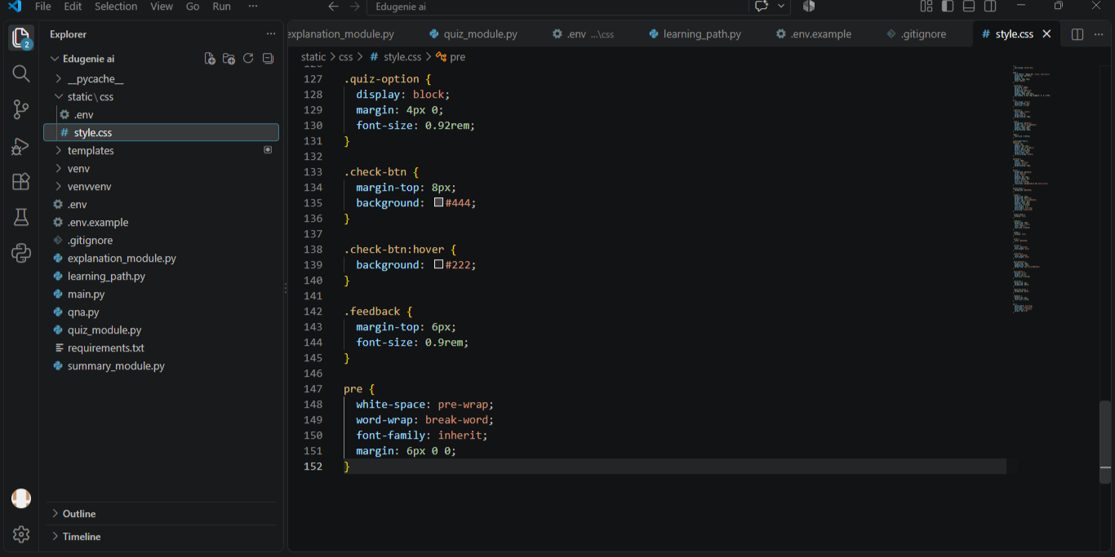
Fig. 6.3 — Stylesheet (style.css) rendered in VS Code

7. Deployment & Functional Testing

7.1 Running the Application Locally
With dependencies installed and the .env file configured, the application is started with a single Uvicorn command:

uvicorn main:app --reload

The --reload flag enables hot-reloading during development. Once running, the terminal displays “Application startup complete,” and the app becomes accessible at http://127.0.0.1:8000.

7.2 Homepage — Initial Load
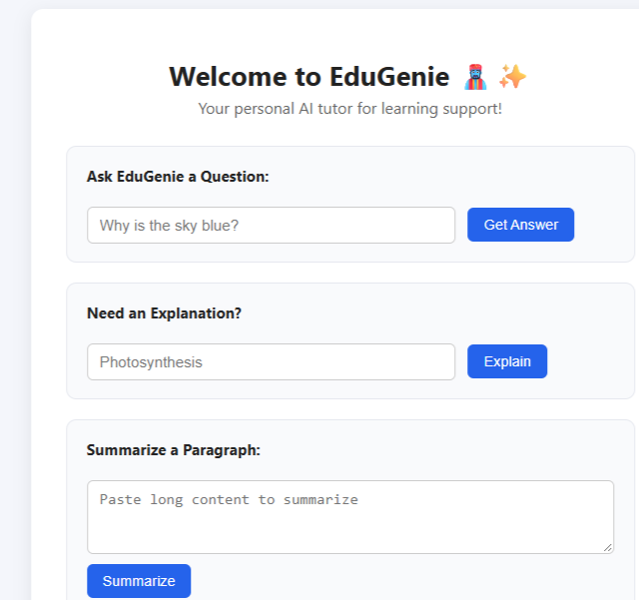
Fig. 7.1 — EduGenie homepage on first load, showing all five module input forms
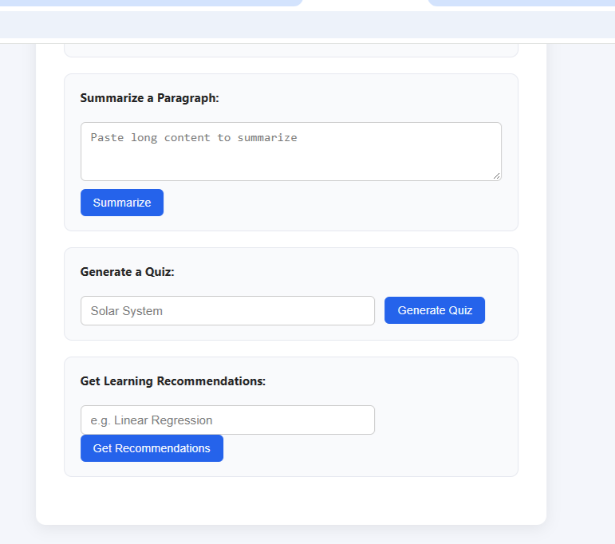
Fig. 7.2 — Full-page view of the Summarize, Quiz, and Learning Recommendation forms

7.3 Functional Test — Q&A Module
Test input: "which is the largest ocean" — Gemini correctly identifies the Pacific Ocean with a brief supporting fact.
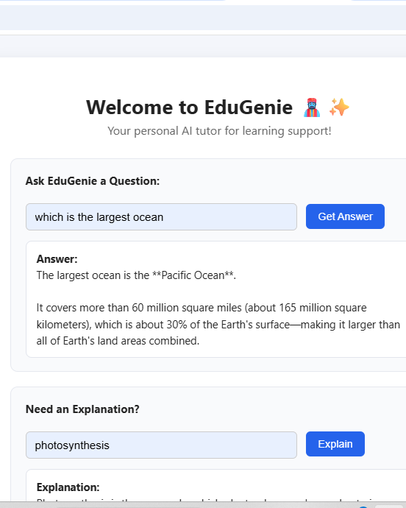
Fig. 7.3 — Q&A module returning a live answer from Gemini

7.4 Functional Test — Explanation & Summary Modules
Test input for Explanation: "photosynthesis" — the local LaMini-Flan-T5 model returns a simplified, age-appropriate definition. Test input for Summary: a climate-change passage — Gemini condenses it into a short, clear revision note.
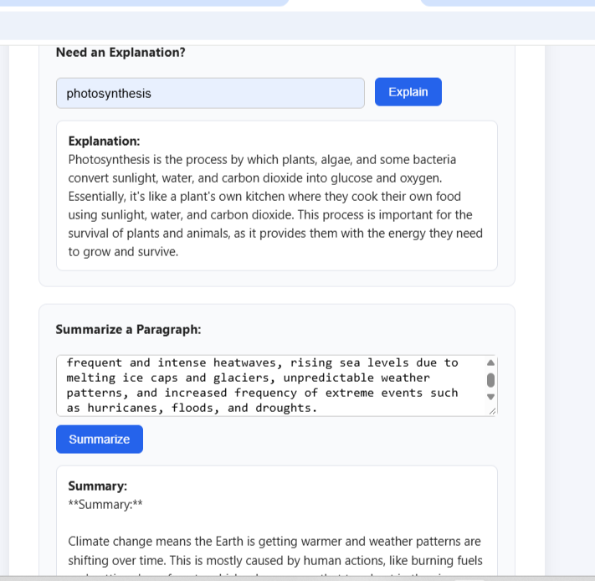
Fig. 7.4 — Explanation and Summarization modules producing live results

7.5 Functional Test — Quiz Module
Test input: "solar system" — EduGenie generates an interactive multiple-choice quiz. Selecting an answer and clicking Check Answer instantly confirms correctness.
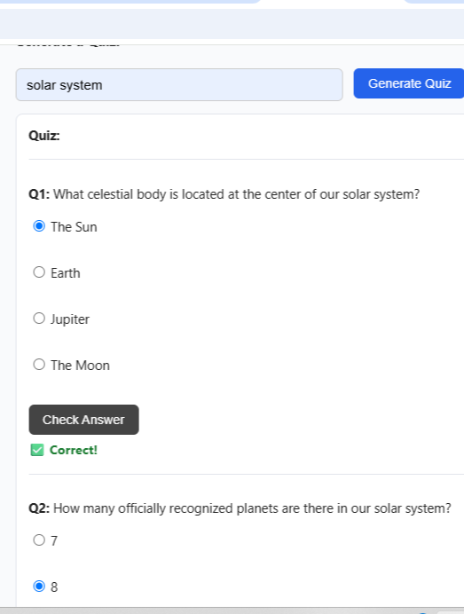
Fig. 7.5 — Interactive quiz generated for the topic “solar system”

7.6 Functional Test — Learning Path Module
Test input: "linear regression" — Gemini returns a structured, multi-level roadmap with a pre-assessment guide to help the learner choose a suitable starting point.
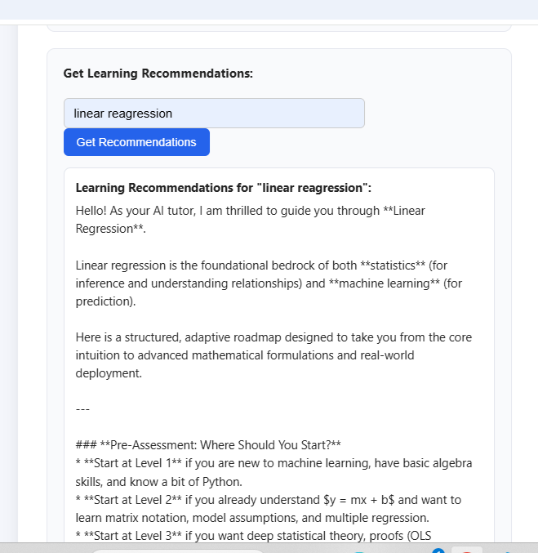
Fig. 7.6 — Structured learning path generated for “linear regression”
All five core modules — Q&A, Explanation, Summarization, Quiz Generation, and Learning Path Recommendations — were verified end-to-end, from user input through FastAPI routing, AI model inference, and live rendering in the browser.

8. Conclusion, Challenges & Future Enhancements

8.1 Conclusion
EduGenie has been developed as a robust and accessible AI-powered educational assistant that seamlessly integrates cloud-based intelligence with an intuitive, low-footprint web interface. Designed to support self-learners, educational institutions, and content platforms, EduGenie democratizes learning by simplifying complex concepts, providing instant question-and-answer interactions, generating personalized quizzes, offering detailed summaries, and tailoring smart learning paths based on individual needs.
Its lightweight infrastructure ensures that even users with minimal hardware resources can access high-quality, personalized education without barriers. The modularity of the platform further allows for easy future upgrades, while its cloud-based backend ensures scalability and data-driven intelligence.

8.2 Technical Challenges Overcome
- Prompt Engineering: Iteratively refining prompts to Gemini to reliably return well-structured, valid JSON for the Quiz module, including defensive Markdown-fence stripping.
- Model Availability & Versioning: Adapting the model_name configuration as Gemini model generations were deprecated and replaced (e.g., migrating from gemini-1.5-pro through gemini-2.5-flash to gemini-3.8-flash) without disrupting the module interfaces.
- Response Accuracy: Balancing generation parameters (temperature, top_k, top_p) on the local explanation model to keep answers concise, age-appropriate, and factually grounded.
- UI Optimization: Designing a single-page, card-based layout that stays clear and usable across five distinct AI features without overwhelming the learner.
- Secure Configuration Management: Ensuring API keys are never hard-coded, are loaded exclusively via .env, and are excluded from version control through .gitignore.
- Resilient Error Handling: Every module gracefully degrades — returning a clear, human-readable error message rather than crashing the request — whether the cause is a missing key, invalid model name, or malformed AI response.

8.3 Future Enhancements
- Voice-based interaction, enabling hands-free learning through spoken queries and responses
- Multilingual support to bridge language barriers and reach a broader global audience
- A dedicated mobile application with offline-capable features for uninterrupted access
- Progress-tracking dashboards, visualizing each learner's journey through metrics and insights
- Gamified elements — badges, learning streaks, and challenge-based assessments
- Image and PDF upload support, enabling snapshot-based doubt solving and document summarization
- Integration with Learning Management Systems (LMS) such as Moodle or Google Classroom
- Group study sessions and teacher/parent dashboards for collaborative learning

9. Submission Details

Field | Details
Submitted by | Miruthynjayan.R
Mentor | ________________________
Date | ________________________

— End of Document —

